Oauth New Token Step

Objective

A Refresh Token is a special kind of token that can be used to obtain a renewed access token that allows accessing a protected resource at any time. You can request new access tokens until the refresh token is blacklisted. Refresh tokens must be stored securely by an application because they essentially allow a user to remain authenticated forever.

UI

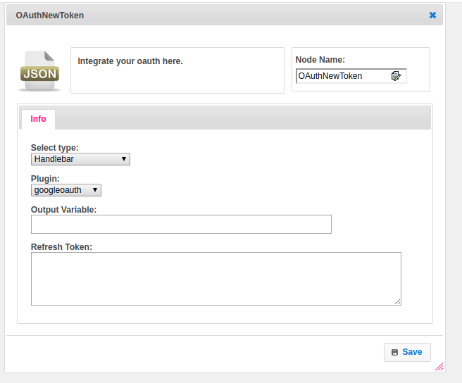

**Attributes**

|  |  |
| --- | --- |
| **Attributes** | **Description** |
| **1. Select Type** | Select Type used to set the value type.  Value types are two types.  1.hb-HandleBars  2.ftl-Freemarker Template Language. |
| **2. Plugin** | Contains the name of the plugin. |
| **3. Output Variable** | Used to store the response of the request. |
| **4. Refresh Token** | Provide the token |

## Executor Description:

Getting respective identity provider builder service.Getting Oauth20Service object based on the type of Oauth. Getting refresh token using scribe methods. Setting Complete Refresh token entity details to output variable

## Resource:

For more information please find the below link.

<https://auth0.com/learn/refresh-tokens/>